Cognitive Inference 1: A Model of the Universe's Extremes of Scale
As illustrated in the figure below, we categorize celestial bodies, fundamental forces, particles, and radiation waves as follows:Celestial bodies: Earth, the Sun, neutron stars, black holes, singularitiesFundamental forces: strong nuclear force, weak nuclear force, gravitation, electromagnetic forceParticles: molecules, atoms, electrons, nucleons, gravitonsElectromagnetic waves: infrared radiation, radio waves, visible light, gamma rays, gravitational waves
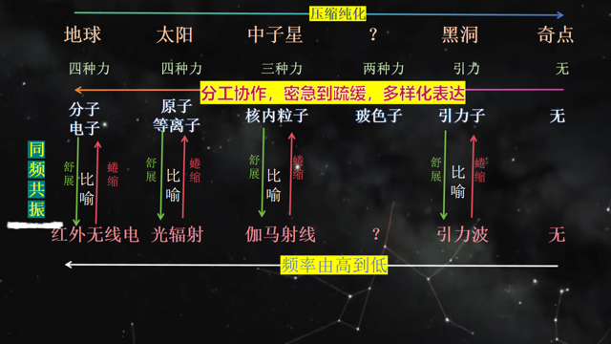
From this classification, we can identify an evolutionary pattern governed by the Theory of Periodic Iteration through Resonance at the Same Frequency. The key conclusions are as follows:
- As frequency decreases, wavelength increases. Particle systems represent the fundamental level of periodicity, and through iteration, they give rise to more complex and higher-order particle systems.
- Due to imperfection in their structure and operation, particle systems at different hierarchical levels rely on compensatory mechanisms to sustain their existence—and fundamental forces are the tangible manifestation of such compensation.
- Celestial bodies are both formed by periodic processes and serve as the environmental framework that sustains these periodicities.
- A particle system is itself both a periodic entity and an environment for other periodic processes. New particle systems emerge through periodic iterative evolution, which in turn drive the formation of even more novel particle systems. In this way, each particle system provides the environmental guarantee necessary for the operation of periodic processes within itself.

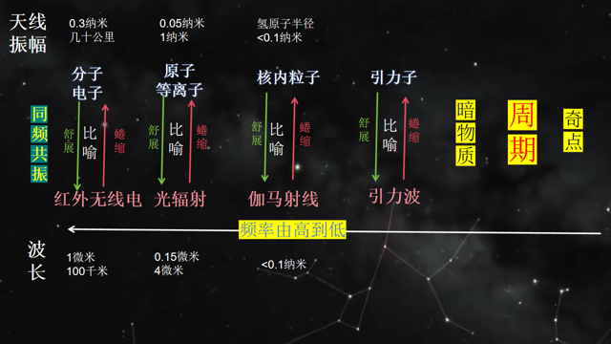

Key Points for Understanding
- Particles must be regarded as integrated systems. The properties we attribute to particle systems from the perspective of the macroscopic world—such as mass, volume, electric charge, and velocity—are interpretations based on our understanding of macroscopic objects. To achieve a more objective understanding of particle systems, we need to adopt entirely new frameworks of comprehension.
- As a general principle, celestial bodies, fundamental forces, particles, and radiation waves that share the same frequency should be studied and analyzed as an interconnected whole. A profound grasp of resonance at the same frequency is essential to this research approach—and this principle is also applicable to other fields, including education and management.
- Building on this foundation, we can attain a deep understanding of the mechanism of resonance at the same frequency: the mutual interactions and energy/matter exchanges that occur within a single existential system bound by a common frequency.
- This framework also enables a substantive understanding of light and radiation: Radiation is the external manifestation of the process of periodic iterative change. We can thus answer the question of why radiation exists—radiation itself is a form of periodicity, and as such, it can be fully encompassed and described by the Theory of Periodic Iteration. The frequency of radiation is equivalent to that of the particles that generate or absorb it, a direct manifestation of resonance at the same frequency. From this perspective, radiation and the internal periodic motion systems of co-frequency particles are interconnected and interdependent. In other words, a single proton or electron is, in essence, a vast and complex system analogous to Earth—we simply lack the means to detect the detailed internal structure of particles, forcing us to describe them only in terms of mass, size, and force-related properties. To use a metaphor: a proton is like Earth, and electromagnetic waves are like the air moving within Earth that escapes into the external space. Radiation is therefore an alternative form of periodic existence: unlike particle-based periodicity, which manifests as mass, radiation-based periodicity has no mass. Massless periodic existence manifests its nature through the speed of light—and the speed of light thus becomes a fundamental characteristic that reflects the operational properties of periodicity. Based on this inference, we can subsequently derive a series of conclusions supported by quantitative and data-driven reasoning.
- To understand the evolution of celestial systems, we must deeply comprehend the reciprocal evolutionary relationship between an existential system and its surrounding environment—how each shapes and is shaped by the other in an ongoing iterative process.

